Item  1.  2.  3.  4.  5.  6.  7.  8.  9.  10.  11.  12.  13.  14.  15.  16.  17.  18.  19.  20.  21.  22.  23.  24.  25. | Present:  Cllr Linda Aston chaired the meeting with Cllrs Jane Nesham and Megan Carter.  2 members of the public and clerk were also present. Apologies were received from Kevin D Couling Esq - Lord of the Manor of Cowlinge.  Apologies for absence:  Apologies were received from Cllrs Jones and Wijenayak.  Receive Declarations of Interest from Councillors regarding any agenda item:  No declarations of interest were received.  Open Forum  Discussions were held about the flooding in Mill Lane – see under item 5.  To approve and sign the minutes of the meeting of 16th January 202 to stand as an accurate record  The minutes from the meeting held on Friday 16th January 2026 were approved unanimously by those present.  Highways – Mill Lane and any matters to report:  Council discussed the flooding on Mill Lane; the Clerk had chased Suffolk County Council for an update. They reported that on the cyclical visit on 22nd and 23rd October all the gullies were non-operational, they were logged either as buried or silt bound and in some cases both. All were then dug out, cleared and left operational. A couple of landowners were asked to clear their ditches to stop the water flow onto the road. As all the gullies were running freely after their jetting in October indication is that the problem lies further within the drainage system, they suspect blocked or collapsed pipes under the road or the pipework between ditches. This has now been passed to the drainage team to investigate and prioritise. The recommendation was to keep reporting so this shows as a continuing problem on the Suffolk County Council reporting tool.  Cllrs also discussed the large potholes at the junction of New England Lane and Newmarket Road and the field side on Queens Street. The Clerk had reported both, again it needs continued reports in numbers to get this work prioritised.  Suffolk County Council:  Cllr B Bennett reported that due to boundary changes that after the election if she is successful in re-election she will not be Suffolk County Councillor for Cowlinge. Councillors wished her well and thank her for efforts.  West Suffolk Council:  Cllr I Wijenayaka was not able to attend the meeting but send in this report:  We need to make residents aware and prepared for is the change to recycling process and collections –  In Summary:  New recycling and food waste collections start in June 2026. Exact dates will be published before the change.  Most homes will get:  • A new paper and card recycling bin, these are in the process of being delivered, some residents  may already have these, however, please tell residents not to use these until informed to.  • A food bin for outside and a food caddy for indoors.  We are aiming to deliver the new bins between February and May, All bin deliveries are logged for verification purposes.  Most households will receive:  • one extra 240 litre green lidded recycling bin for their paper and card - approximately 110 cm  high by 59 cm wide by 75 cm deep  • 23 litre food caddy (outside) - 39 cm by 29 cm by 34 cm  • 5 litre kitchen caddy (inside) - 21 cm by 25 cm by 19 cm.  Your current blue bin will continue to be for recycling but will now also include being able to recycle glass bottles and jars, plastic film, metal and cartons (including Tetra Pak). Do not include the additional items for recycling until the exact date has been published by the Council (please)  Due to the new service your bin collection days and schedules may change but we will keep changes to a minimum. We will confirm these changes with you by post nearer the time. Again, Please don’t do any changes prior to confirmation of dates.  From June households will have:  • Food waste collected weekly  • Paper and card (grey recycling bin with green lid) collected once every four weeks  • Mixed recycling (blue bin) collected once every four weeks  • Non-recyclable (black bin) waste collected once every two weeks  • Garden waste (paid for service) collected once every two weeks  Your garden waste collection day will not change.  Forest City 1:  West Suffolk Council has been contacted by the applicant; West Suffolk has concerns with their plans and would need to understand the impacts on our current towns and residents.  Councillor Wijenayaka - My personal view is that this will have a negative impact on our towns and residents.  - I believe it will compete with resources (including water), and serve as a centre of gravity taking investment and funding away from the current areas, such as Cambridge City, Newmarket, Haverhill, Bury St. Edmunds, Brandon, Mildenhall, Clare.  - It will also compete for potential new residents, if there’s a million new homes in an area, why would you consider moving to Haverhill or Newmarket?  - For me the infrastructure map is unclear, how do people travel to this new forest city, is there going to be a High-Speed Link to London, what would that mean for the current Cambridge line? What about traveling to other parts of the county?  - There are a lot of questions that just simply are not answered.  - The scale and location are wrong in my opinion.  - The developer states that we want to live in beautiful places, where business wants to set, yes of course that’s true, but what can’t we invest in our current towns to make the vision real, why do we have to set up something brand new, and here?  - Why was this not including in Sir Michael Lyons’ English New Towns Task Force? Does the new forest city undermine it?  I believe it also undermines the work of West Suffolk with the Brandon Commission and the A11 Corridor Growth work we’ve been doing under my portfolio.  West Suffolk passed our budget for the next 2 years, this included an amendment that will see parking charge reductions across Bury St. Edmunds, Newmarket and Haverhill.  Planning application DC/26/0144/EIASCO Cambridge To Rede Pipeline the Green Depden  Councillors discussed the EIA Scoping - EIA Scoping Opinion under Regulation 6 (1)  of the Environmental Impact Assessment notification from West Suffolk Council and agreed for the Clerk to feedback their concerns to the amount of disruption residents will experience due to the work.  Community Police report  The community police officer Cheryl Claydon advised that there have been two burglaries reported in Cowlinge during the past month. Her scheduled community engagements for March are as follows:  18th March, 12:00–12:30 – Evergreen Estate, Great Bradley  18th March, 12:45–13:15 – Thurlow Sports Club  Finance:  - The Council reviewed the payments and receipts schedule and unanimously agreed approval.  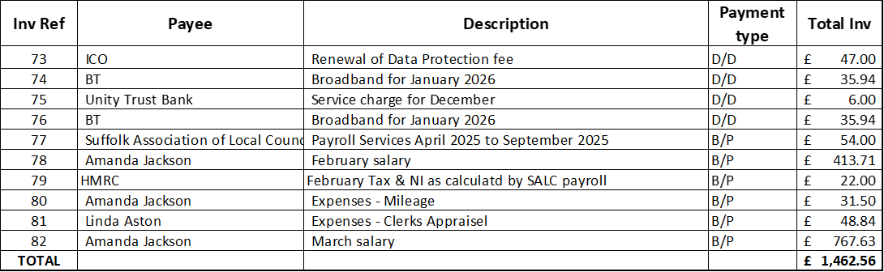  - The Council reviewed the circulated bank reconciliations and unanimously agreed.  - Clerks report – Unity Trust Bank fees will raise from £6 per month to £7 from April 2026.  Future village events  Councillors discussed different ideas and decided on a garden party with a bbq and refreshments in the Village Hall garden. Date to be confirmed. Volunteers would be required from residents to help set up and clear away.  Council to review amended Standing Orders  Councillors reviewed the amended Standing Orders and unanimously agreed to adopt. The Clerk will update the website.  Council to review amended Financial Regulations  Councillors reviewed the amended Financial Regulations and unanimously agreed to adopt. The Clerk will update the website.  Annual Review of Parish Council policies  Councillors reviewed all the policies and agreed there was not need to amend.  Council to review findings of the website accessibility assessment  The Clerk had circulated a report prior to the meeting, Councillors discussed and agreed that some changes were required. The Clerk with speak with the website host to continue improvements.  Council to adopt the new IT policy  Councillors reviewed the new IT policy and unanimously agreed to adopt. The Clerk will upload to the website.  Annual review of Risk Assessments  Council reviewed the risk assessment document and findings. There were no questions.  Review of Internal Controls  Council reviewed its system of internal controls. Councillors considered the arrangements in place and confirmed that they are adequate and effective. It was noted that the annual review of fees had not been completed and this would be added to a future agenda.  Review of the effectiveness of the Internal audit  Council reviewed the effectiveness of the internal audit arrangements. Councillors considered the current internal audit process and confirmed that it remains effective. It was noted that the annual review of fees had not been completed and this would be added to a future agenda.  Council to consider and appoint an Internal Auditor for the 2025/26 year  Councillors discussed and agreed to appoint David Wedgwood as our Internal Auditor for 2025/26 accounts.  Council to consider applying for a Communities Capital Fund  Councillors discussed capital asset ideas that a grant from West Suffolk Council’s Communities Capital Fund could help with and decided to apply for 2 smaller pieces of play equipment for the village hall garden. The Clerk will complete and submit the grant application.  Review of Clerks’ annual appraisal  The Clerks appraisal took place on 26th February 2026 and Council agreed in line with the contract of employment to increase the hourly rate for 7 hours a week.  Correspondence  No correspondence was received.  Matters for consideration at the next meeting  Garden party  New photo of the village  Next meeting date:  Monday 20th April 2026 7.30pm – Annual Village meeting  Monday 5th May 2026 7.30pm – Annual Parish Council meeting  There being no further business the Chairman thanked the Councillors for their attendance and closed the meeting at 9.02pm  ………………………………………………………………….. sign and date  ……………………………………………………………………print name  Chairman  Signed as confirmation that they are a true record. | Action

