
Minutes of the meeting of Cowlinge Parish Council Monday 11th May 2026 held in the Village Hall

Item  1.  2.  3.  4.  5.  6.  7.  8.  9.  10.  11.  12.  13.  14.  15. | Present:  Cllr Linda Aston chaired the meeting with Cllrs Jane Nesham and Megan Carter.  The Clerk was also present. There was 1 member of the public.  PROCEDURAL INFORMATION FOR THE COUNCILS ANNUAL MEETING  - To elect a Chairman - Cllr Carter proposed Cllr Aston seconded by Cllr Nesham, unanimous decision.  - Cllr Aston accepted and signed the declaration of acceptance of office and advised there were no updates to the register of interests form.  - To elect a Vice Chairman – Cllr Carter proposed Cllr Nesham seconded by Cllr Aston, unanimous decision. Cllr Nesham accepted and signed the declaration of acceptance of office.  - Cllr declared there were no updates to their register of interest forms.  - To appoint a Responsible Financial Officer – Cllr Aston proposed Amanda Jackson the Clerk, this was seconded by Cllr Carter, unanimous decision.  Chairmans welcome and to receive any apologies:  Cllr Wijenayak sent his apologies.  To receive members declarations of interest and to consider any new written requests for dispensation:  There were no declarations of interest or written requests for dispensation.  OPEN FORUM – 5 minutes is set aside for members of the public to raise any Parish matter.  A resident raised the following:  Why solar panels had been fitted houses by Suffolk County Council when they faced North.  There would be some hedge cutting at the edge of the field/ditch on Mill Lane.  To notify that an area of a green lane is being blocked by tree branches.  West Suffolk Council – report from Councillor Indy Wijenayaka  Cllr Wiienayaka had sent the following report:  Over the last 12 months the council has worked with the Government to on Local Government Reorganisation. It has been the position of West Suffolk Council, as the motion brought forward by the West Suffolk Working Partner, and voted on by members that the Government consider the formation of a Western Suffolk Unitary Council, as opposed to the proposal put forward by Suffolk County Council of a One Suffolk Unitary to cover to whole of Suffolk County. It is will great relief to me and many of my councillor colleagues that the Government has stated that its preferred option is also to form a Western Suffolk Unitary. I know some political parties and interests are looking to challenge the Government on this; however, I do hope they won’t be successful and the Government is allowed to restructure district and county service for the area into the Western Suffolk Unitary.  The Better Recycling is coming into service soon, but now residents should have had all the new recycling bins, and the information needed to adjust to the new way of recycling for the area. From June, specific dates to be advised, will be,  Green lidded bins will be for Paper and Cardboard  Grey food caddies, will be for food waste, the larger caddy is for the collection and a smaller in-home caddy is there to help keep the waste ready for putting into the larger caddy  Blue bins will be for the new service of glass bottles, tetra pack, plastic film, as well as other plastics.  Black bins are as normal for General waste as normal.  Locality Budget will be being refreshed again, now that the election is completed, I’ll advise again on the forms to complete etc, but please do think about what you might want funding for.  I know Forest City has been a recent issue of great concern to residents, and I share that concern, I do feel the developer is a long way off making any tangible realistic progress.  Sunnica has also been a long-standing issue, however you would have seen in the local news that it’s up for sale, I don’t know the impact of that sale as such, but I shall find out what I can.  Suffolk County Council – report from Councillor Bobby Bennett  Cllr Bennett was unable to attend the meeting.  Highways – Mill Lane flooding  A representative from Suffolk County Council will be attending a future parish council meeting to explain why Mill Lane keeps flooding and what steps can be taken to remedy the situation. Date to be confirmed.  Council to approve and adopt the minutes of the full Council meeting held on Monday 2nd March 2026  The minutes from the meeting held on Monday 2nd March 2026 were approved unanimously by those present.  Cambridge to Rede Pipeline village presentation  Councillors discussed and agreed to ask Anglian Water to attend an information evening at the village hall so Cllrs and residents can understand the effects the pipeline work will have on the village and surrounding area.  Village Garden Party update  No updates at present.  FINANCE  - The Council reviewed the payments and receipts schedule and unanimously agreed approval.  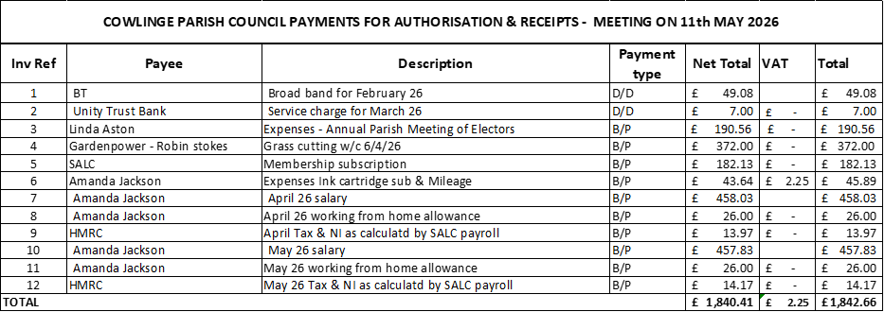  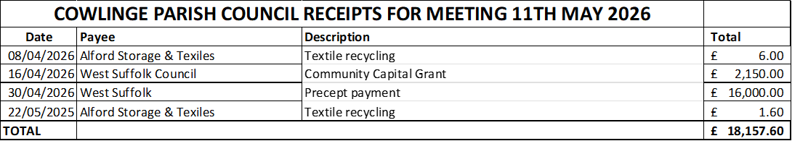  - To approve and sign the circulated bank reconciliations - The Council reviewed the circulated bank reconciliations and unanimously agreed.  - Annual review of reserves and earmarked funds – Council reviewed the report circulated by the Clerk prior to the meeting showing one earmarked reserve for Village events £950.00 as at 31st March 2026. Cllrs unanimously agreed to keep this reservice unchanged.  - Council to review plans for any underspend from 2025/26 budget – Council reviewed a report circulated by the Clerk prior to the meeting showing the underspend from the 2025/26 budget. Cllrs agreed to the recommendations of the Clerk to create the following reserves for the underspend in these areas:  Children’s play equipment maintenance £150.00  Village Maintenance £123.00  Grass/verge cutting £700.00  Total for new earmarked reserves £973.00 Plus £210 for village hall hire = £2133.00  - Council to consider changing internal auditor provider to Heelis and Lodge – Council discussed changing internal auditor to Heelis and Lodge as David Wedgwood was unable to completed for 2025/26. Cllr Nesham proposed, seconded by Cllr Carter. Cllrs unanimously agreed.  End of year accounts  - Council to consider, approve and sign section one of Accounting Statement of the 2025/26 AGAR  - Council to consider, approve and sign section two of Accounting Statement of the 2025/26 AGAR  Council were unable to complete items 12 a) and b) and the internal audit had been delayed. These will be included in the June 2026 agenda.  - Council to sign the certificate of exemption of the 2025/26 AGAR – Council discussed and unanimously agreed to sign and approve the certificate of exemption for the 2025/26 AGAR.  - Council confirmed the dates for the exercise of public rights to view the accounts as 3rd June 2026 to 14th July 2026.  - Council considered the statement of variances prepared by the Clerk and had no questions.  - Council reviewed and approved the annual bank reconciliation with no questions.  - Council to consider a meeting in June to review the internal audit report – As the internal audit has been delayed Council agreed to hold a meeting in June to review the findings from the internal audit report. Date to be confirmed.  Good Governance – continuing Procedural items  - Council reviewed and approved the use of variable direct debit to pay West Suffolk Council (bin emptying), Information Commissioners Office (data protection), Unity Trust Bank (banking fees) and BT (village hall wifi). Cllr Aston proposed, seconded by Cllr Nesham. Unanimously agreed.  - Council conducted its annual review of Parish Council asset register there were no changes. Cllr Carter proposed seconded by Cllr Aston. Unanimously agreed.  - Council conducted its annual review of insurance cover and comparison against the asset register to confirm Council are adequately insured, after discussion Cllr Aston proposed that Council were adequately insured seconded by Cllr Nesham. Unanimously agreed.  - Council conducted its annual review of Risk Assessments; there were no changes. Cllr Aston proposed no changes seconded by Cllr Carter. Unanimously agreed.  - Annual Review of Parish Council policies:  IT Policy  Privacy Policy  Document Retention Policy  Data Protection Policy  Freedom of Information Policy  - Council conducted its annual review of LGA Code of Conduct and readopted.  - Council conducted its annual review of Standing Orders Cllr Aston proposed no changes seconded by Cllr Nesham. Unanimously agreed.  - Council conducted its annual review of Financial Regulations Cllr Aston proposed no changes seconded by Cllr Nesham. Unanimously agreed.  Correspondence – any received to date  A resident had reported that City Fibre workers had been using the air aid shelter as a toilet whilst working in the village. The resident and the Clerk had complained to City Fibre who had apologised and advised they would send a team to completely clean the area.  A couple of anonymous suggestions were received in the suggestion box.  Matters for consideration at the next meeting  Review of the internal auditors report  Council to consider, approve and sign section one of Accounting Statement of the 2025/26 AGAR  Council to consider, approve and sign section two of Accounting Statement of the 2025/26 AGAR  Village garden party update  Highways meeting  Anglia Water meeting  Date for next meetings:  The next meeting date is Monday 6th July 2026  There being no further business the Chairman thanked all present for their attendance and closed the meeting at 8.54pm  ………………………………………………………………….. sign and date  ……………………………………………………………………print name  Chairman  Signed as confirmation that they are a true record.

