
Minutes of the Extra Ordinary meeting of Cowlinge Parish Council Monday 8th June 2026
held in the Village Hall

Item  1.  2.  3.  4.  5.  6.  7.  8.  9.  10.  11.  12. | Present:  Cllr Linda Aston chaired the meeting with Cllrs Robert Jones and Megan Carter.  The Clerk was also present. There were no members of the public.  Chairmans welcome and to receive any apologies:  Apologies were received from Cllr Nesham.  To receive members declarations of interest and to consider any new written requests for dispensation:  There were no declarations of interest or written requests for dispensation.  Open Forum – 10 minutes in total is set aside for members of the public to raise any Parish matter.  None.  To approve and sign the minutes of the meeting of 11th May 2026 to stand as an accurate record  The minutes from the meeting held on Monday 11th May 2026 were approved unanimously by those present and signed by the Chair.  Highways – any matters to report  Cllr Aston advised that there appeared to be some form of traffic survey being carried out before and after Upper Elm Farm on Elms Road, this is not the traffic survey commissioned by the Parish Council. The Clerk will investigate. Both of the outstanding pot holes have been repaired at the bottom of New England Lane and Queens Street.  Planning applications  Council discussed and agreed there was no reason to not support the 3 planning applications below.  DC/26/0723/LB - Dowells Farm Bradley Road Cowlinge - Application for listed building consent - replace existing telephone cable with new fibre optic cable with a fibre optic connection box to the outside wall.  DC/26/0682/LB - 1 Factory Cottages Pound Green Cowlinge - Application for listed building consent - installation of fibre broadband box.  DC/26/0831/VAR - 2 Elms Cottage Newmarket Road Cowlinge - Planning application - variation of condition 2 (approved plans) of DC/24/0254/HH to enable for the use of amended plans for Householder planning application - conversion of existing garage to annexe comprising a. single storey extension to north elevation b. first floor side extensions c. dormer to east elevation.  Council to consider allotment training for the Clerk  Council discussed a one day online training course provided by SALC about allotments. Council agreed this would be very useful as the parish council have 1 allotment. Cllr Aston proposed the training for the clerk at a cost of £36.00. Seconded by Cllr Carter. Unanimously agreed. The Clerk and Cllr Carter will liaise on all matter’s allotment following the training.  FINANCE  - The Council reviewed the payments and receipts schedule and unanimously agreed approval.  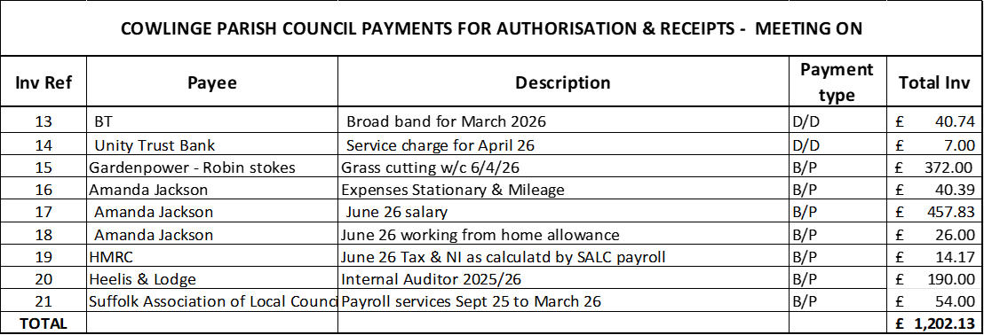  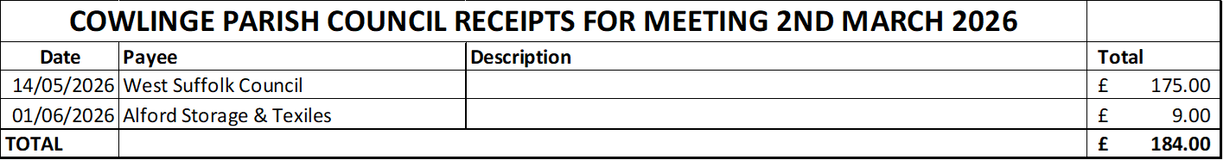  - To approve and sign the circulated bank reconciliations - The Council reviewed the circulated bank reconciliations and had no questions.  - Clerks report:  The Clerk reported that the verges will cut at junctions over the next 14 days.  The Clerk advised that Anglian Water have agreed to a village open evening to discuss the Cambridge to Rede Pipeline and how it will affect the village, the date is to be confirmed. Cllrs viewed a revised map showing the location of the pipeline works. There will be some excavations over the next few months surveying and assessing also some trial trenching to identify whether there are any archaeological features or remains with the area.  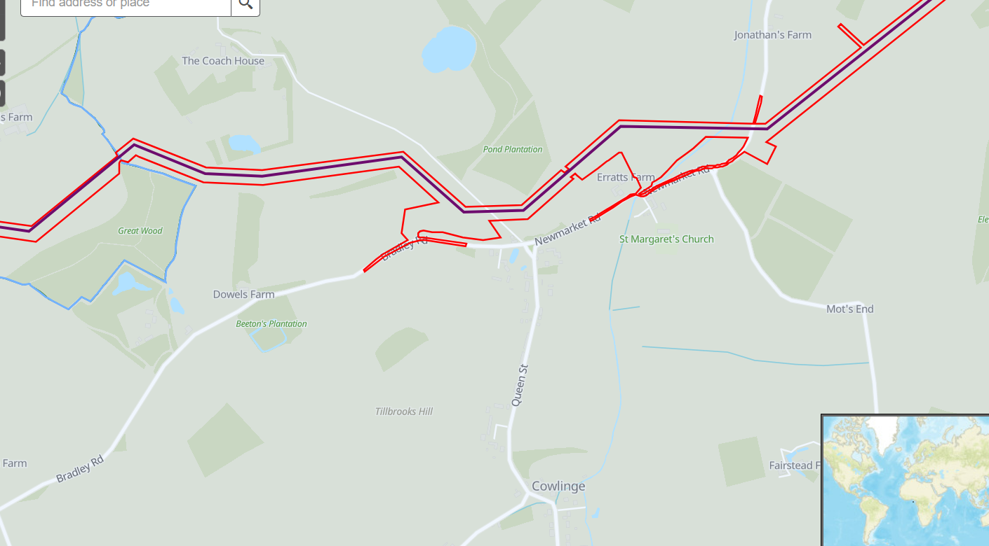  Cllr Carter suggested the parish council could consider making some boards that can be placed around the village to help inform resident of this and future events. Cllrs unanimously agreed this would be a good idea and will be added to July’s agenda.  Village Garden Party – there were no updates.  End of year accounts  - Council to consider the internal audit report and recommendations – Council reviewed the circulated internal auditors report, there were no recommendations. Cllr Aston thanked Amanda Jackson the Clerk for all her hard work preparing the documentation.  - Council to consider, approve and sign section one of Accounting Statement of the 2025/26 AGAR – Council considered, approved and signed section one of Accounting Statement of the 2025/26 AGAR.  - Council to consider, approve and sign section two of Accounting Statement of the 2025/26 AGAR – Council considered, approved and signed section two of Accounting Statement of the 2025/26 AGAR.  Correspondence – any received to date  None.  Matters for consideration at the next meeting  Boards to advertise events through the village  Village garden party update  Highways meeting  Cambridge to Rede pipeline works - Anglia Water village meeting  Date for next meeting:  The next meeting date is Monday 6th July 2026  There being no further business the Chairman thanked all present for their attendance and closed the meeting at 8.35pm  ………………………………………………………………….. sign and date  ……………………………………………………………………print name  Chairman  Signed as confirmation that they are a true record.

