
Minutes of the meeting of Cowlinge Parish Council Monday 6th July 2026 held in the Village Hall 7.30pm

Item  1.  2.  3.  4.  5.  6.  7.  8.  9.  10.  11.  12.  13.  14.  15. | Present:  Cllr Linda Aston chaired the meeting with Cllrs Robert Jones and Megan Carter. Kevin D Couling Esq - Lord of the Manor of Cowlinge, 2 members of the public and the Clerk was also present.  Chairmans welcome and to receive any apologies:  Apologies were received and accepted from Cllr Nesham.  To receive members declarations of interest and to consider any new written requests for dispensation:  There were no declarations of interest or written requests for dispensation.  Open Forum – 10 minutes in total is set aside for members of the public to raise any Parish matter.  A resident raised the question as to why solar panels have been fitted to some properties in the village facing the wrong direction by either West Suffolk Council or Suffolk County Council.  A resident also advised again that lengths of wood are sometimes obscuring green lane blocking rights of way. They advised they will no longer be able to cut the vegetation back.  Councillor Luke O’Brien introduced himself as the new Suffolk County Councillor. He reports that Suffolk County Council have launched a legal challenge to the government’s decision for 3 unitary councils. There is a proposal to reclassify the B1061 route to stop heavy goods traffic.  To approve and sign the minutes of the meeting of 8th 2026 to stand as an accurate record  The minutes from the meeting held on Monday 8th June 2026 were approved unanimously by those present and signed by the Chair.  Highways – Matthew Fox Community Liaison Engineer from Suffolk County Council Highways will attend to discuss Mill Road flooding  The Clerk reported that, during the cyclical drainage maintenance visit on 22 and 23 October 2025, all gullies on Mill Lane were found to be non-operational, having been recorded as either buried, silt-bound, or, in some locations, both. Following completion of the maintenance works, all gullies were confirmed as having been excavated, cleared and returned to full operation. In addition, four landowners within the parish were requested to clear adjoining ditches, and all complied with the request. Despite these works, further flooding has occurred, indicating that the underlying issue is likely to lie elsewhere within the drainage network. It is suspected that sections of the clay pipework may be blocked, root-bound or collapsed beneath the highway, or within the pipework connecting the ditches. The matter has been referred to Suffolk County Council's Drainage Team for further investigation and prioritisation. Matthew Fox advised that all flooding incidents within the village should continue to be reported using Suffolk County Council's reporting tool and that each occurrence should also be supported by photographs submitted by email to the Clerk. He explained that this evidence assists with prioritising drainage works. The case has moved from position 381 to 231 on the current prioritisation list. Members discussed the possibility of the Parish Council, together with Cllr O'Brien, making a financial contribution towards the drainage works to help expedite repairs. Matthew Fox advised that this may be a possible option. Matthew Fox will discuss the available options with the Drainage Team and report back to the Parish Council.  Planning applications  Council discussed Householder planning applications DC/26/0828/HH and DC/26/0829/LB Brookside Cottage Farm Queen Street Cowlinge - a. 1.5-storey link extension between dwelling and existing rear extension b. removal of modern dormers and removal of modern link structure and objected to the proposal. The Clerk will submit comments to West Suffolk Council.  Allotment training update  The Clerk reported that the allotment training was very interesting, she and Cllr Carter will work together to improve the current systems and documentation inline with the training. There were no questions from Counsellors.  Cambridge to Rede pipeline works - Anglia Water village meeting  An evening presentation for the village will be organised for either August or September. The Clerk will confirm the date and design a leaflet/poster to advise residents.  Traffic survey results  The traffic survey results had not arrived in time for the meeting and will be included in the September meeting.  Village garden party update  There were no updates.  Council to consider the cost of changing website provider  The Clerk presented costs to change our website host and design template, Cllr Carter proposed the change with a budget of £700 made up of £300 set up and transfer but not village data, £250 annual website and email hosting, £150 for 2 hours of training and annual accessibility assessment. Seconded by Cllr Aston. Unanimously agreed.  Council to consider which new playground equipment to purchase using the Communities Capital funding  Council considered options for an additional piece of playground equipment to be sited in the village hall garden. Cllrs agreed a trim trail that could be added to over the years would work well. Cllr Aston proposed 1 piece of trim trail equipment up to a value of £2500 to include installation. The awarded grant of £2150 received from West Suffolk Council Rural England Prosperity Fund will be used as part of the £2500. Seconded by Cllr Carter. Unanimous decision.  FINANCE  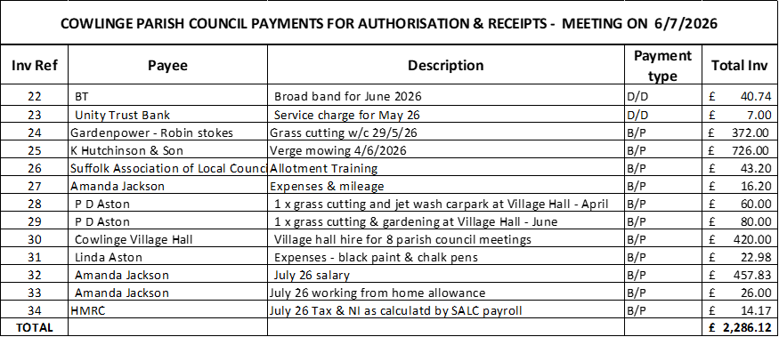  - The Council reviewed the payments and receipts schedule and unanimously agreed approval.  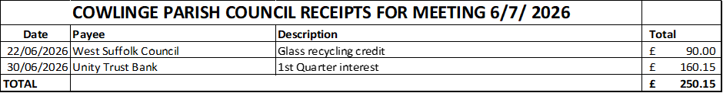  - To review and sign the circulated bank reconciliations - The Council reviewed the circulated bank reconciliations and had no questions.  - Clerks report:  The Clerk reported receipt of £160.15 interest from the savings account.  End of year accounts update  The Clerk reported that all documentation required had been emailed to PFK Littlejohn the external auditor.  Correspondence – any received to date  None.  Matters for consideration at the next meeting  Village garden party update  Cambridge to Rede pipeline works - Anglia Water village meeting  Website hosting update  Play equipment update  Christmas events  Highways update  Date for next meeting:  The next meeting date is Monday 7th September 2026  There being no further business the Chairman thanked all present for their attendance and closed the meeting at 9.20pm  ………………………………………………………………….. sign and date  ……………………………………………………………………print name  Chairman  Signed as confirmation that they are a true record.

