
Minutes of the Extra Ordinary meeting of Cowlinge Parish Council Tuesday 4th August 2026 held in the Village Hall 7.30pm

Item  1.  2.  3.  4.  5.  6.  7.  8. | Present:  Cllr Linda Aston chaired the meeting with Cllrs Jones and Nesham. 1 member of the pubic and the Clerk were also present.  Apologies for absence:  Apologies were received and accepted from Cllr Carter.  To receive Councillors declaration of interest regarding any agenda item  There were no declarations of interest.  Open Forum:  There were no questions.  To approve and sign the minutes of the meeting of 6th July 2026 to stand as an accurate record  The minutes from the meeting held on Monday 6th July 2026 were approved unanimously by those present and signed by the Chair.  DC/26/1047/FUL | Planning application - Change of Use of Grain Store to Use Class E (d) for use as a padel court with associated parking  Council discussed the planning application and voted unanimously to support in principle. Councillors were concerned for the amount of traffic if the business runs at full capacity and if the future pickle ball court application also proceeds. The Clerk will submit comments to West Suffolk Council.  FINANCE  - The Council reviewed the payments and receipts schedule and unanimously agreed approval.  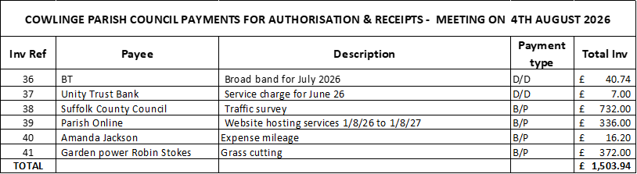  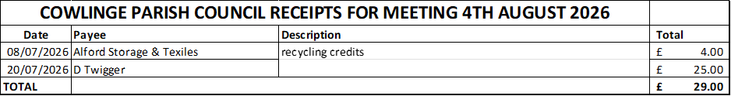  - To review and sign the circulated bank reconciliations - The Council reviewed the circulated bank reconciliations and had no questions.  Matters for consideration at the next meeting  Cambridge to Rede pipeline works - Anglia Water village meeting  Play equipment update  Christmas events  Date for next meeting:  The next meeting date is Monday 7th September 2026  There being no further business the Chairman thanked all present for their attendance and closed the meeting at 8.35pm  ………………………………………………………………….. sign and date  ……………………………………………………………………print name  Chairman  Signed as confirmation that they are a true record.

